**LAB NO. 08**

**INTRODUCTION TO PROLOG**

**ACTIVITY-1:**

|  |  |  |
| --- | --- | --- |
| DECLARATIVE | PROLOG FACT | RELATIONSHIP OR PROPERTY |
| SSUET is university | **university(ssuet)** | **university** |
| Faheem likes icecream | **likes(faheem,icecream).** | **likes** |
| Birds can fly | **fly(birds).** | **fly** |
| Switch is off | **off(switch).** | **off** |
| Sara is enemy of Saima | **enemy(sara,saima).** | **enemy** |

**ACTIVITY-2:**

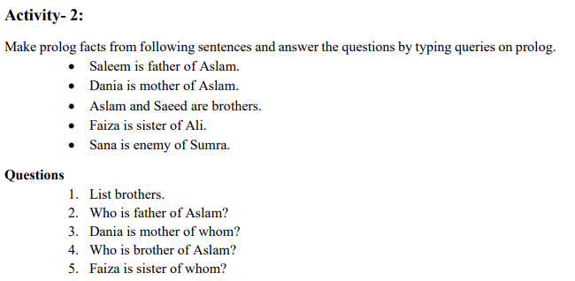

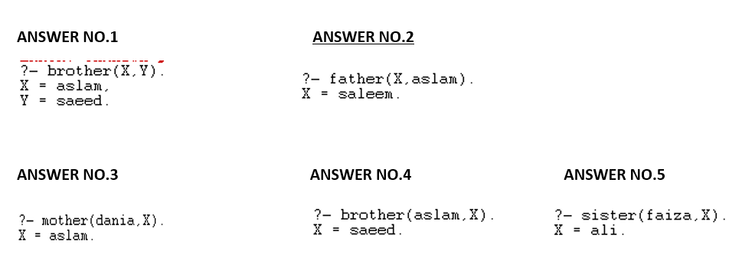

**ACTIVITY-3:**

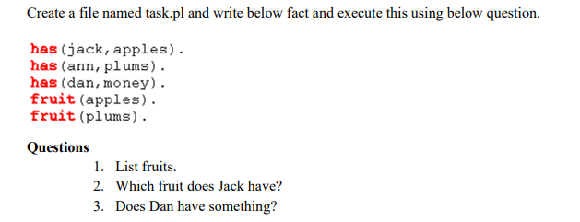 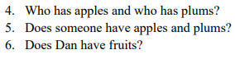

**ANSWER NO.1**



**ANSWER NO.2**



**ANSWER NO.3**



**ANSWER NO.4**



**ANSWER NO.5**



**ANSWER NO.6**



**ACTIVITY-4:**

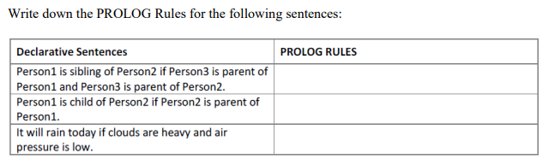

**rain(today):-heavy(clouds),low(air_pressure).**

**child(P1,P2):-parent(P2,P1).**

**Sibling(P1,P2):-parent(P3,P1),parent(P3,P2).**

**ACTIVITY-5:**



**PROGRAM IN PROLOG:**

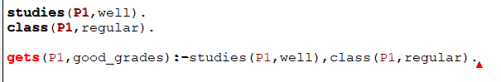

**OUTPUT:**

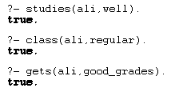

**ACTIVITY-6:**

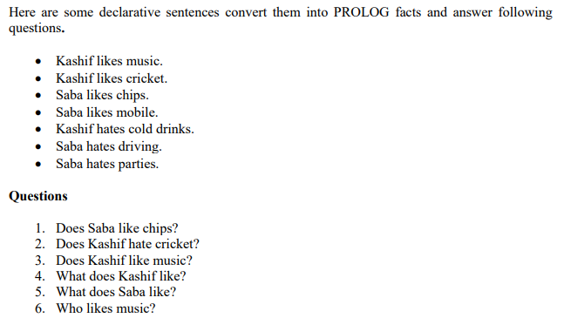

**ANSWERNO.1:**



**ANSWER NO.2**



**ANSWER NO.3**



**ANSWER NO.4**



**ANSWER NO.5**



**ANSWER NO.6**



**ACTIVITY NO.7:**

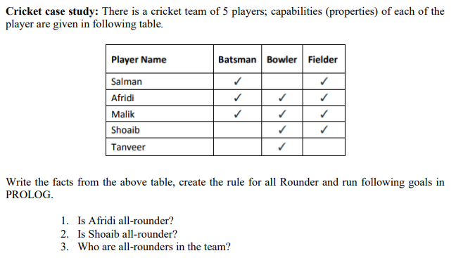

**FACTS & RULE:** 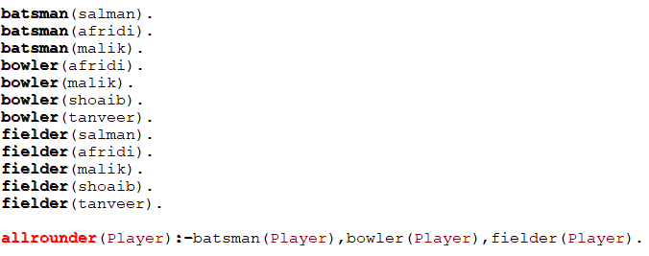

**ANSWER NO.1**



**ANSWER NO.2**



**ANSWER NO.3**



**ACTIVITY NO.8:**

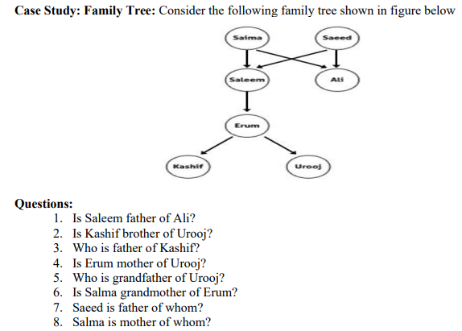

**PREDICATES & CLAUSES:**

**ANSWER NO.1:**



**ANSWER NO.2:**



**ANSWER NO.3: ANSWER NO.4:**



**ANSWER NO.5: ANSWER NO.6:**

**ANSWER NO.7: ANSWER NO.8:**

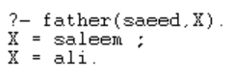

**ACTIVITY NO.10:**

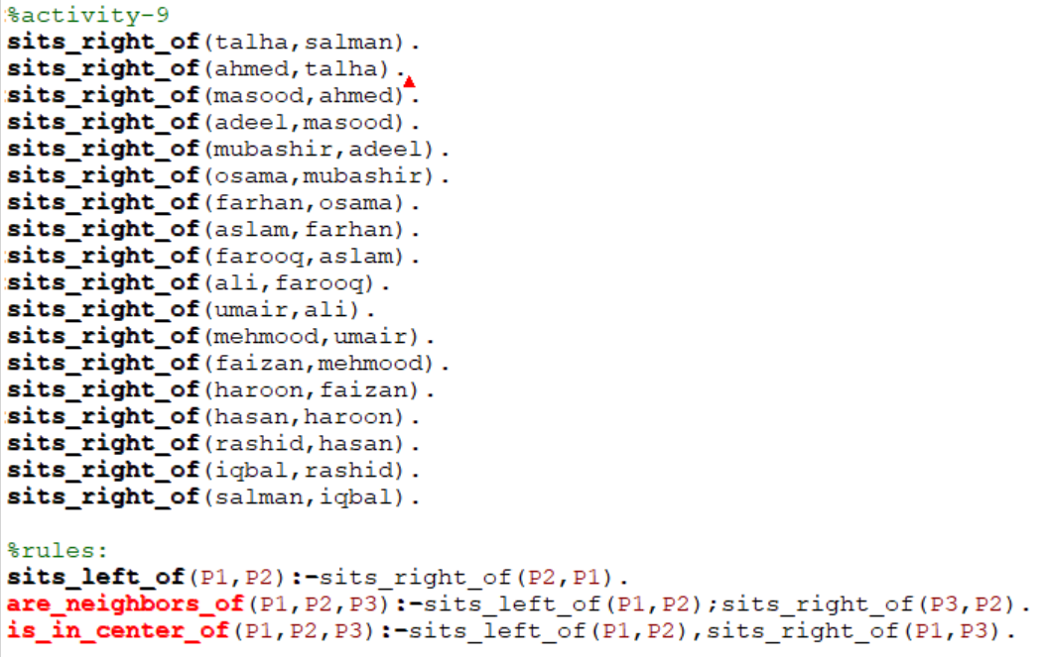

**ANSWER NO.1:**

**ANSWER NO.2:**

**ANSWER NO.3:**

**ANSWER NO.4:**

**ANSWER NO.5:**



**ACTIVITY NO.11:**

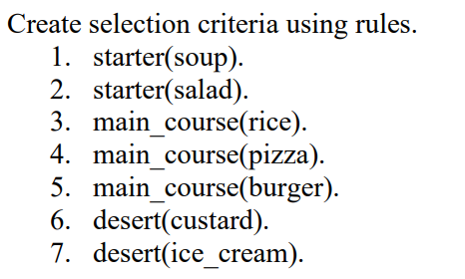

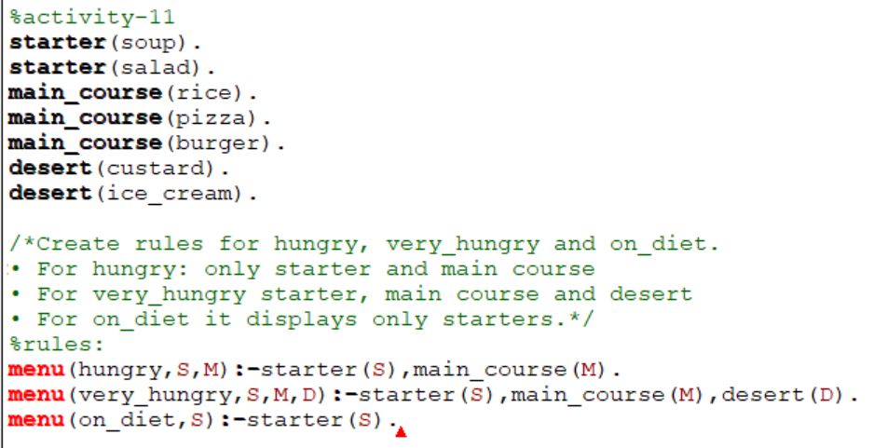

**ACTIVITY NO.12:**



In Prolog, the built-in predicate **max/2** takes only two arguments and is used to determine the maximum of two values. If you need to determine the maximum number from a list of ten numbers, you can use the **max_list/2** predicate along with the **max/2** predicate. 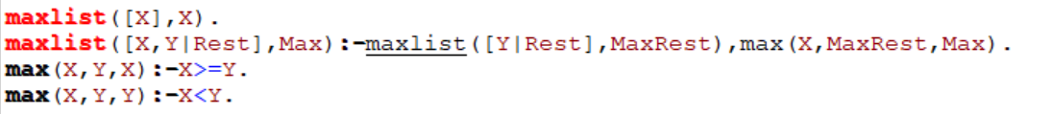



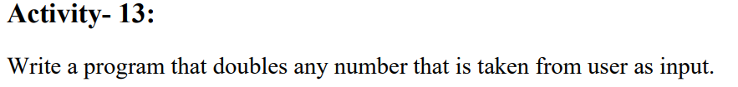

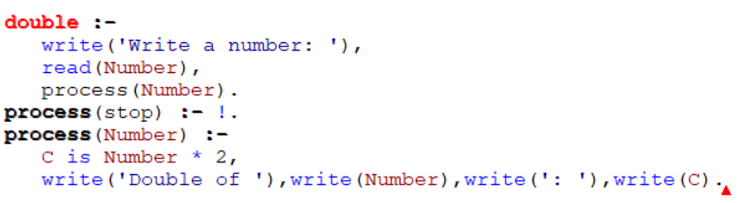

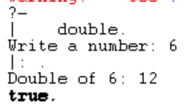

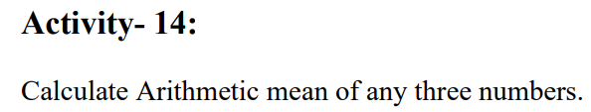



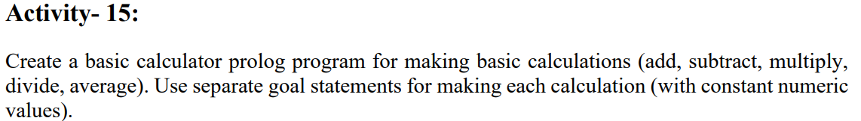

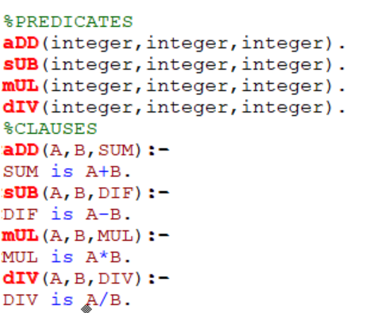

**OUTPUT:**

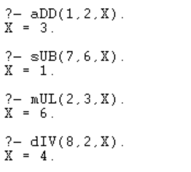

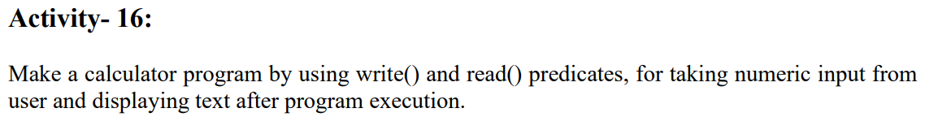

**CLAUSES:**

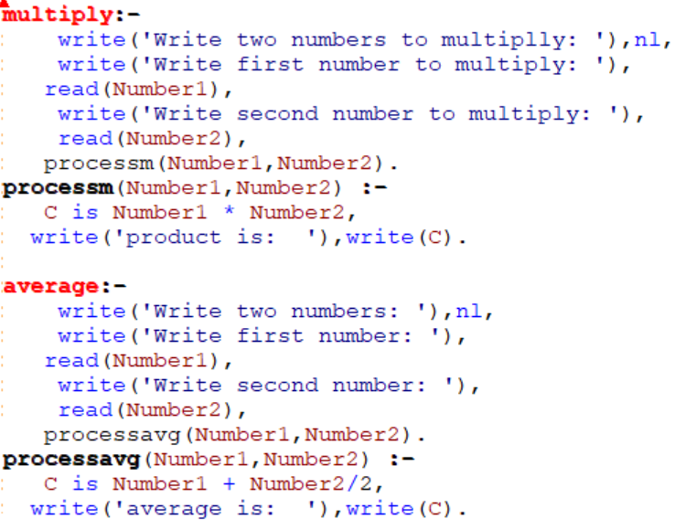

**OUTPUT:**

